Muhammad Murad Khan

S/O Muhammad Tariq Khan

Assistant Professor (OPS) (BPS-18) Mobile Number: +92 332 7077774

Department of Computer Science muradtariq.tk@gmail.com

Government College University muhammadmurad@gcuf.edu.pk

Faisalabad

Education

**PhD Computer Science**, Universiti Teknologi Malaysia Completed:2019

Skudai, Johor, Malaysia

**MS Information Security**, Universiti Teknologi Malaysia GPA: 4.00/4.00

Skudai, Johor, Malaysia

National University of Science and Technology , Pakistan GPA:3.54/4.00 BE (Computer Systems Engineering : 88.5%) September 2010 (PEC: COMP/8772)

Divisional Model College, Faisalabad Marks: 872/1100

Higher Secondary School Education (1ST Division) June 2006 Grade: A

Divisional Model College, Faisalabad Marks: 730/850

Matriculation Education (1ST Division)June 2004 Grade: A

Research Interests

Recommender Systems, Artificial Intelligence, Neural Networks, Software Engineering,

Blockchain, Machine Learning, Web Scraping, Data Mining

Publications with impact factor

|  |  |  |  |  |
| --- | --- | --- | --- | --- |
| **SNO** | **Title** | **Year** | **Journal / Conference** | **IF(JCR)** |
| 1 | Cross domain recommender systems: A systematic literature review | 2017 | ACM Computing Surveys (CSUR) 50.3 (2017):  1-34 | 6.748 |
| 2 | Facebook interactions utilization for addressing recommender systems cold start problem across system domain | 2018 | Journal of Internet Technology 19.3 (2018): 861-870 | 1.301 |
| 3 | Impact of rooftop photovoltaic on energy demand of a building in a hot semi-arid climate | 2021 | Journal of Renewable and Sustainable Energy  13.6(2021): 065101 | 14.98 |

LINK : https://doi.org/10.1063/5.0063044

IF: 14.98

Journal: JOURNAL OF RENEWABLE AND SUSTAINABLE ENERGY

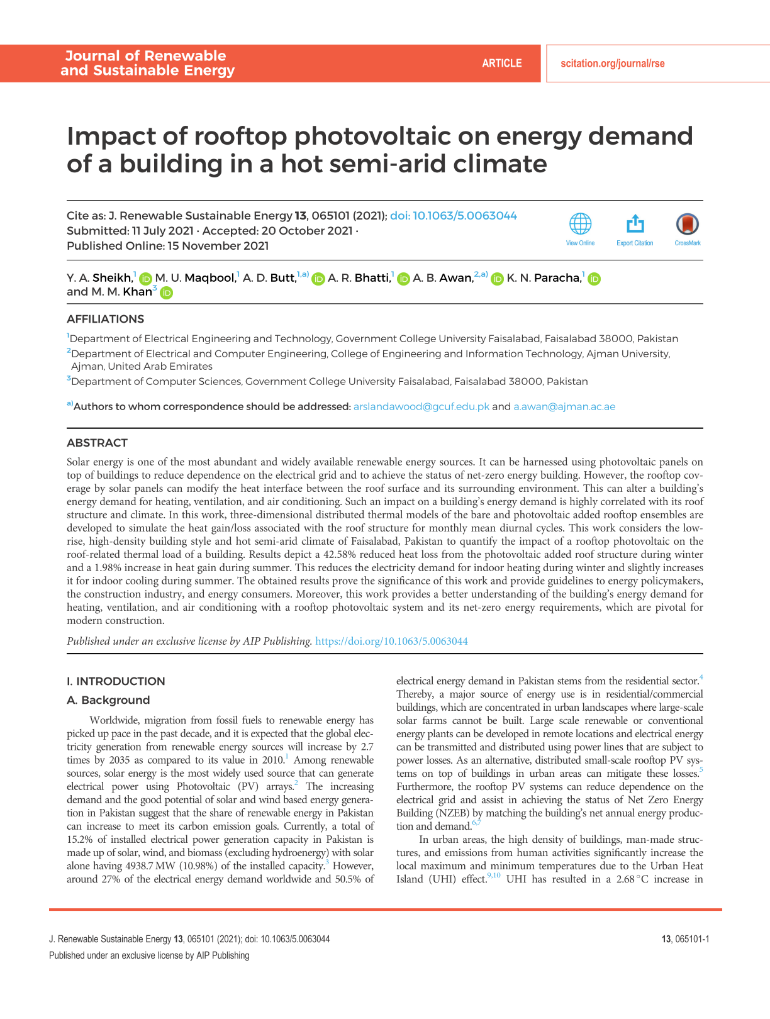

LINK : https://dl.acm.org/doi/abs/10.1145/3073565

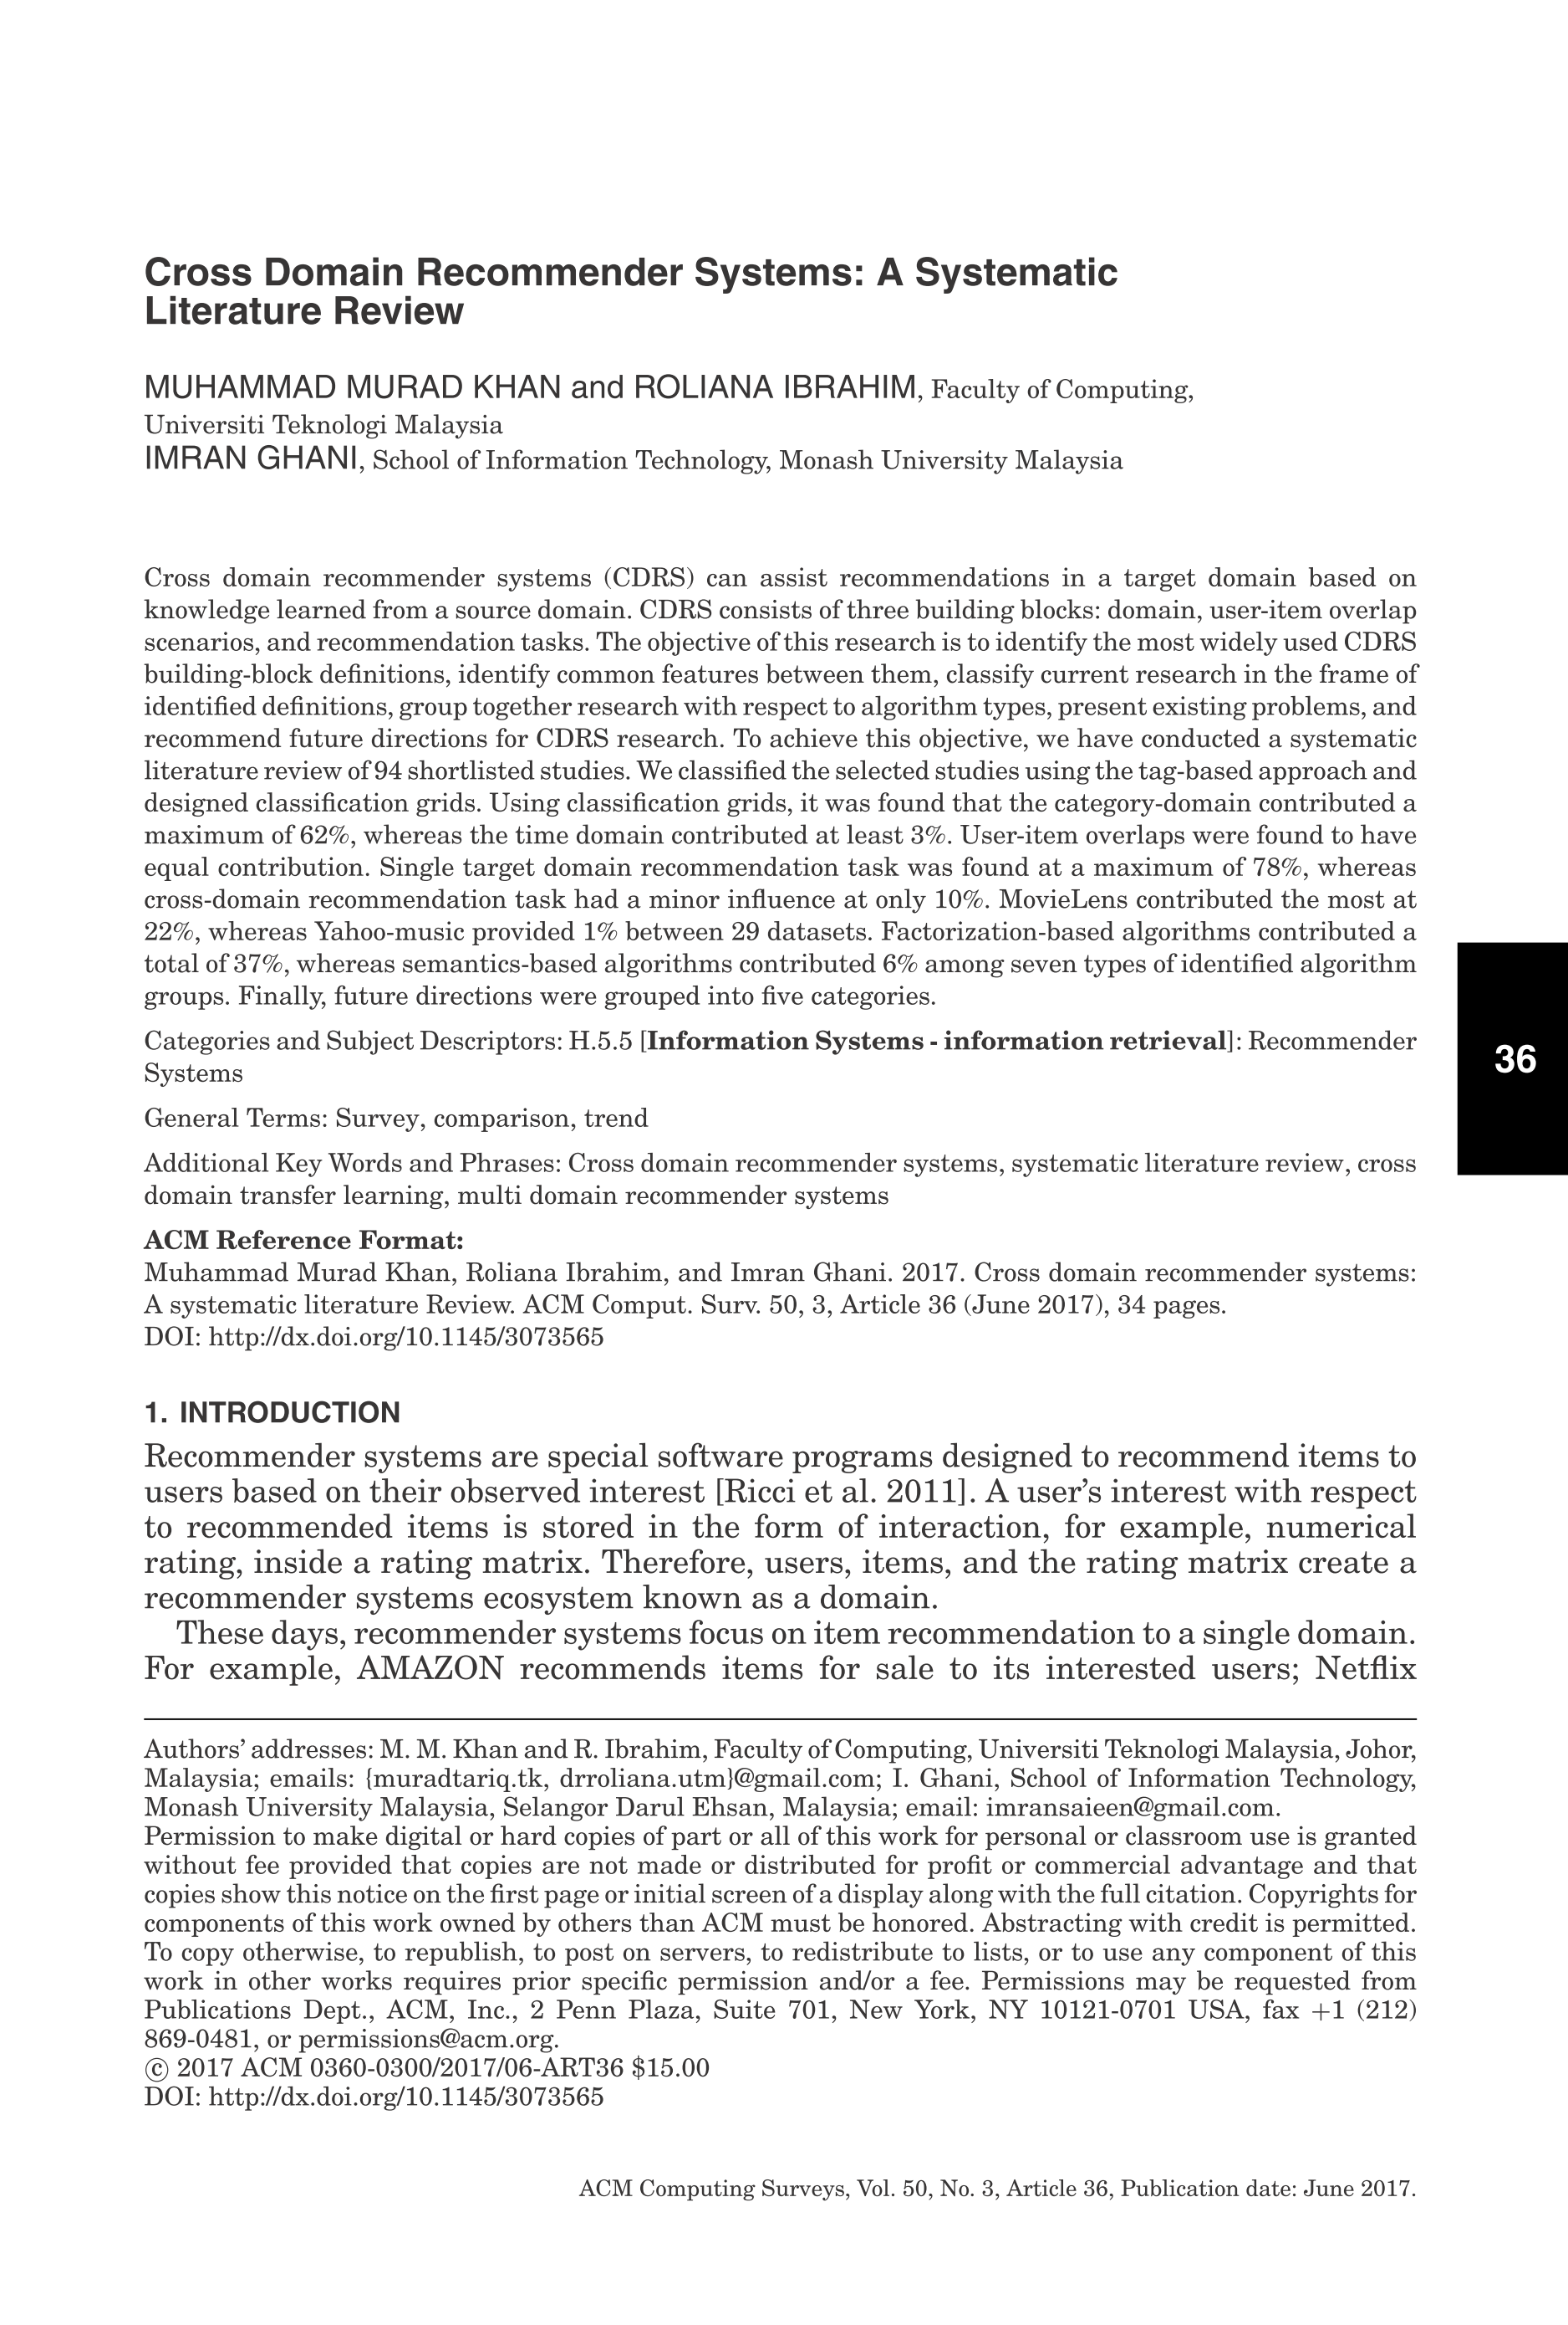

IF: 6.78

Journal: ACM COMPUTING SURVEYS

LINK : https://jit.ndhu.edu.tw/article/view/1703

IF: 1.301

Journal: JOURNAL OF INTERNET TECHNOLOGY

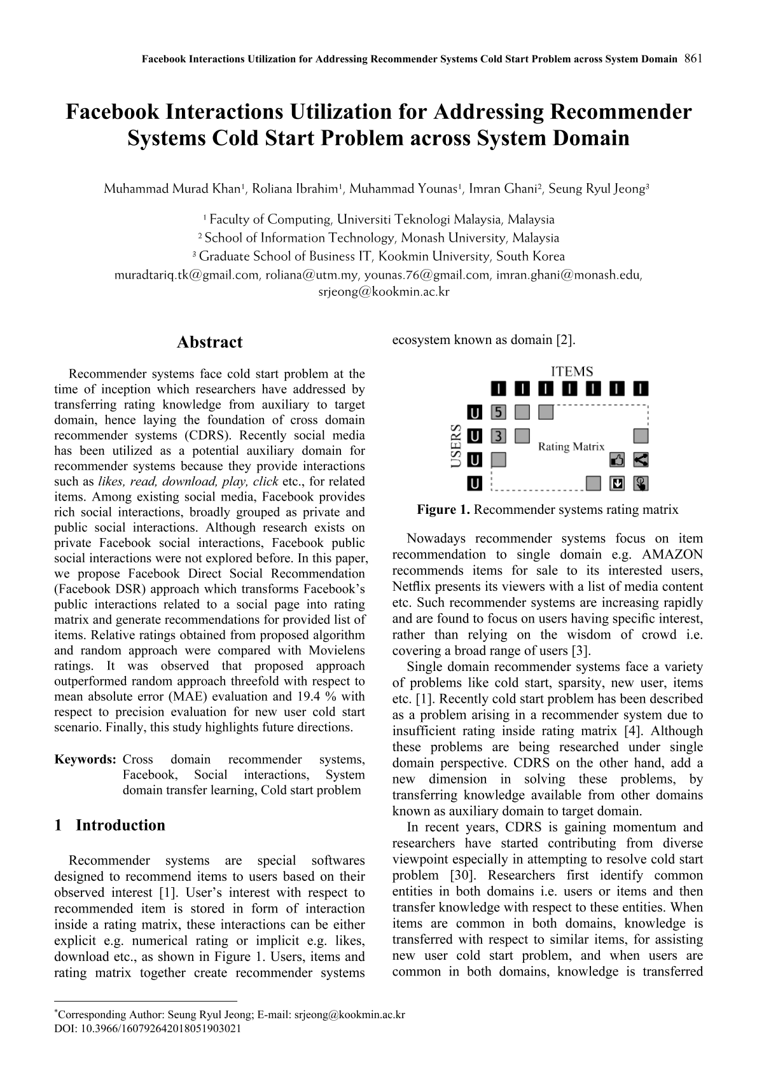

Publications without impact factor

|  |  |  |  |
| --- | --- | --- | --- |
| **SNO** | **Title** | **Year** | **Journal / Conference** |
| 1 | A Review of Blockchain based Educational Projects | 2019 | Journal of Theoretical & Applied Information Technology 10.10 (2019). |
| 2 | Use of Blockchain in Education: A Systematic Literature Review | 2019 | Asian Conference on Intelligent Information and Database Systems. Springer, Cham, 2019. |
| 3 | A Generic Framework for Cross Domain Recommendation | 2019 | Intelligent Information and Database Systems: Recent Developments, 13, 323. |
| 4 | Use of Blockchain in governance: A systematic literature review | 2019 | Journal of Theoretical & Applied Information Technology 10.5 (2019). |
| 5 | Use of blockchain in healthcare: a systematic literature review | 2019 | Journal of Theoretical & Applied Information Technology 10.5 (2019). |
| 6 | A Survey of Agile Transition Models | 2016 | Emerging Innovations in Agile Software Development. IGI Global, 2016. 141-164. |
| 7 | Facebook’s public social interaction utilization to assist recommendation across system domain | 2016 | J. Theoret. Appl. Inf. Technol 88.3 (2016): 392. |
| 8 | Trade-off between automated and manual testing: a production possibility curve cost model | 2016 | Int. J. Advance Soft Compu. Appl, 8(1), 12-27. |
| 9 | Social media usage in academic research | 2016 | Journal of Theoretical & Applied Information Technology 87.2 (2016). |
| 10 | Review on SQL injection protection methods and tools | 2015 | Jurnal Teknologi 77.13 (2015): 49-66. |
| 11 | An HTTPS approach to resist man in the middle attack in secure SMS using ECC and RSA | 2013 | 13th International Conference on Intelligent Systems Design and Applications. IEEE, 2013. |

Supervised Students

|  |  |  |
| --- | --- | --- |
| **SNO** | **Title (MS)** | **Student Name ( Registration #)** |
| 1 | Detection of malicious webpages through Logistic Regression | Asif Ali (2019-GCUF-000477) |
| 2 | Real estate price prediction for Padua using linear regression | Maria Ajmal (2019-GCUF-01779) |
| 3 | Rental prediction for cultural destination using long short-term algorithm | Sidra Sharif (2019-GCUF-01590) |
| 4 | Used car prices prediction for Lativan car market using linear regression | Ferwa Javeed (2019-GCUF-000886) |
| 5 | Predicting the cost of living in Malaysia using logistic regression | Muhammad Faheem Nazir (2019-GCUF-01605) |
| 6 | Malware detection in android mobile application using logistic regression and deep learning | Muhammad Ahsan UL Haq (2019-GCUF-01368) |
| 7 | Fuel price prediction for Spanish retail fuel market using long short-term memory algorithm | Saira Batool (2019-GCUF-02644) |
| 8 | Analysis of Different Blockchain using Smart Contract Platform | Sultan Afzal  (2013-GCUF-01239) |
| 9 | Impacts of Blockchain on Governance with respect to Finance | Asad Razzaq  (2013-GCUF-00605) |
| 10 | HPWS: A novel Block chain Consensus Protocol | Abdul Noman  (2013-GCUF-00958) |
| 11 | The Blockchain-Based Solution for EMR issues and challenges | Sohaib Saleem  (2017-GCUF-011210) |
| 12 | Use of Cloud-Based Blockchain Platform And Applications in Healthcare Sector: opportunities And challenges | Sobia Yaqoob (2017-GCUF-011211) |
| 13 | Use of Blockchain in Internet of things | Malik Muhammad Afrasyab  (2017-GCUF-011268) |
| 14 | Voting empowerment Through Blockchain | Kamran Shahzad  (2017-GCUF-011171) |

Work Experience

Assistant Professor (OPS), Computer Science Dept Government College University

November 2019 - Till Now Faisalabad, Pakistan

IT MANAGER Government College University

December 2021 – Till Now Faisalabad, Pakistan

Lecturer, CS Dept Government College University

April 2011 – November 2019 Faisalabad, Pakistan

Currently, I am serving as Assistant professor at computer science department. I have taught multiple courses such as mobile application development, information security, machine learning and datascience. I am also supervising M.Phil and PhD students.

My other responsibility is being an IT Manager for the GCUF. As an IT Manager my vision is to provide IT Services according to the standard set by HEC and PHEC. After taking charge, I have divided workforce into three teams, i.e., Network, Operations and Development. Members of the operations team were performing well even taking charge, whereas, for the first month, special attention was given to the Networking team. Number of members are increased in Networking team and now satisfactory internet services at the new campus is the highest priority. Development team is maintaining the existing code, however, for the month of February, development team will be given special tasks for improving portals according to the submitted requirements.

Network Administrator Ravi Exchange Company (Pvt LTD),

March 2010 - April 2011 Lahore, Pakistan

Before joining GCUF, I Worked as Team Leader and Network Administrator in IT Department of Ravi Exchange Company (PVT LTD). Work experience included configuration / maintenance of Server Machines, Software, Network devices and structure. As backbone of company was a financial software so consistent connection between 42 branches and head office was main objective of IT Team. I also developed a web application that served as a ticket system for problems faced by branches related to it.

Team Consisted of Network Administrator/Head IT , 2 assistants and 2 sub   
assistants. Teamwork was the only essence of Stable IT Infrastructure. During my job I worked on IBM 3850 Enterprise Server , Microsoft ISA & IIS server, Asterisk server etc. I also did Network devices configurations (IP Cameras, Routers, Printers), IP Schemes for Internal and External systems, SQL Server , Portforwarding , Remote Assistance using teamviewer etc.

Adobe Flash development Intern FIDES Software House

February - March Islamabad, Pakistan

Company was establishing an online Advertisement Management System, Signed   
Partners uploaded their Bills, Cards, Printed material on website where that allocated   
free space for advertisement and interested companies advertised on free space. I   
developed online Module that allowed Signed partners to upload, plot free space on   
printed materials, set price for it and similarly Module allowed interested companies to   
bid on add spaces.

Honors & Awards

1. Was among Chief Organizer in COMPPEC Competition held at NUST. 2. Seven (out of Eight) times GPA Scholarship form E.M.E NUST.

3. I achieved First position in Matricular Examination in my College, DMC Faisalabad.   
4. Fourth position in Alhamra Calligraphic Design Competition , DMC Faisalabad.   
5. I was a member of Team 612 , Chantilly Robotics USA. Our Team Won Most

Prestigious award of F.I.R.S.T Competition Held in USA.

6. 2nd Award for website design in Team 612(Chantilly Robotics) . F.I.R.S.T USA (2006).

Technical Skills

Programming Languages:

Most experienced in **Python,** C/C++, Java , Action Script, Javascript and Matlab

Other skills:

RapidMiner, R, Wordpress Web Development, OpenCV, OpenGL, Adobe Flash, Basic Network Structuring.

Workshops & Trainings

Attended CCNA Training for 2 months at CORVIT Lahore.

Attended SAP Workshop “SAP Overview” at AMKAST Solutions Lahore.

Membership

IEEE Student Member, Monthly Magazine subscription.